Football Player Valuation Model

Business Use Case and Summary

It’s no question that football is the world’s most popular sport. It’s a game that’s in every corner of the world, transcending borders, cultures, and ethnicities. In some regions, fervent fanaticism for the sport is even more intense than the most devout religious following. But whether you call it *soccer* or *football*, one fact about it remains undeniable: the magnitude of the sport – from an economic standpoint – has grown at an exponentially and unprecedentedly high rate over the last few decades. To some, that growth is getting out of hand.

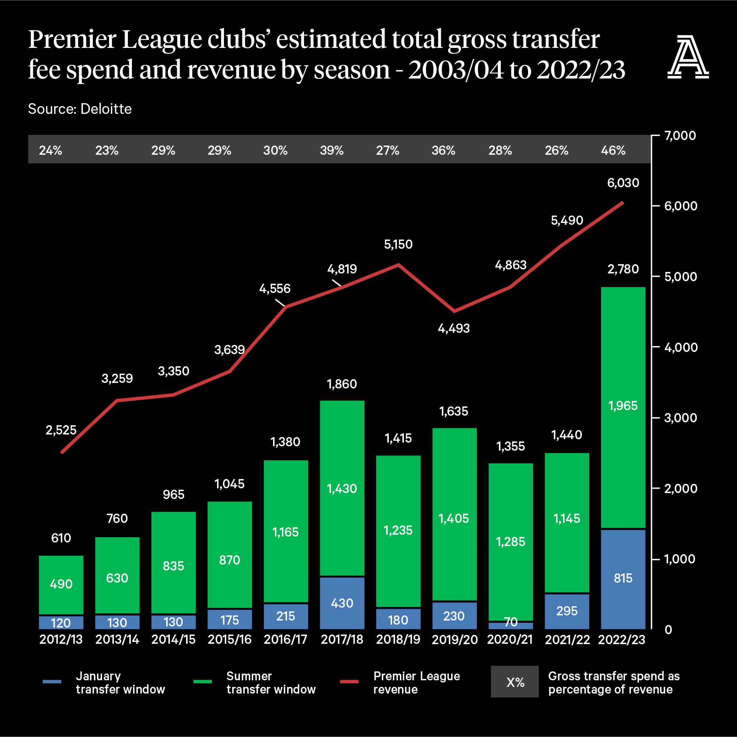A football club’s roster evolves constantly. Teams regularly buy and sell players in their never-ending quest for championship titles and accolades. However, as teams become increasingly more competitive to win on the field, they’ve equally become more persistent in pushing the limits of their spending to improve off the field. As a result of the extravagant (some may say excessive) spending on player talent over the last 10 years, the value of the player market has become hyperinflated. Between 2010 and 2019, the amount of transfer fees payed by teams in the Big-5 leagues tripled from €1.5 billion to a new record of €6.6 billion, although that total did fall slightly during the pandemic. On its own, the Premier League, undoubtedly the most popular and financially strongest of all leagues, increased its net transfer spend by 67% from 2021 to 2022 alone. The individual value of players has risen by more than 9% on average over the past decade: a player that would have cost 1 million euros in 2014 now fetches a price tag of over 2.1 million euros. In fact, according to FIFA, the top ten player transfers alone generated 12.5% of the entire amount that was spent on transfer fees in 2022.

So, what’s the issue with this frenzied spending? Surely more investment in talent would result in better quality of play and attract a greater attendance to games. The main concern is that, at the end of the day once all the spending is complete, the bill needs to fall on somebody. Unfortunately, it is the fans that have had to take on the majority of these amplified financial burdens. Fans pay for these overpriced transfer fees through increased ticket price and matchday concessions. In England, the cost of supporting a team at a game is far outpacing the reasonable budget an average layperson can dedicate to leisure activities. According to a survey in the [Daily Mail](http://www.dailymail.co.uk/sport/football/article-2485471/Next-generation-danger-priced-game-Gary-Neville-column.html), 22% of fans at football games in England in 1983 were under 16, but by 2013 the number had declined to just 9 per cent. The overriding reason is younger fans find it increasingly difficult to afford to attend games because over the last 25 years the average price of a top-flight ticket has increased, in some instances, by more than 1,000%.

Even if teams avoid passing the debt onto fans, they still need to conceive of other ways to generate the funds for their spending. In some instances, teams have resorted to unsavory means, such as engaging in fraudulent accounting practices, taking on massive amounts of debt, and excessively commercializing the team through the sale of sponsorships.

Evidently, such an exorbitant level of spending is highly unsustainable. A tool is needed to help clubs better estimate a reasonable price to pay for a given player of interest. By being more diligent in their spending and taming their overzealous inclination to blow the budget on transfer fees, they can foster a more affordable and enjoyable experience for fans and create a more financially secure and sustainable future for the club without compromising the strength of the talent they field.

We recommend our player price prediction model as a tool through teams can generate an appropriate amount they should pay for a player that embodies all the qualities and abilities they seek to add to their roster. This way, the purchase they make will be based on a reasonable, mathematic deduction instead of hype drawn from the overinflated market.

Sources

<https://theathletic.com/3560989/2022/09/03/premier-league-transfer-window-spend-net/>

<https://www.fifa.com/legal/media-releases/fifa-publishes-global-transfer-report-2022-with-all-time-record-setting-numbers>

<https://football-observatory.com/IMG/sites/mr/mr47/en/>

https://bleacherreport.com/articles/2616164-more-premier-league-fans-need-to-rise-up-to-defeat-ticket-price-greed